AbSim Translation Instructions

*Sean McCullough*

*January 13, 2020*

A Guide to Translating Your AbSim Software

This document provides easy-to-follow instructions to help you translate AbSim’s user interface into the language(s) of your choice. All you need to do is provide the translation, and we will do the rest!

Please follow the step-by-step process below:

Step 1: Receiving the AbSim Translation Template

Now that you have decided you wish to translate AbSim’s text into the language that best fits your needs, you need to first make sure you have received and downloaded AbSim’s Translation Template: “ab_sim_all_text.pot” (or “ab_sim_no_cases.pot” if you do not wish to translate case vignettes at this moment)

This file contains all of the AbSim’s English text. Using a program called Poedit (which we will explain further below), you can view each line of text and provide a translation. If you have trouble finding or accessing this file, please email a representative with AbSim, and we will help you.

Step 2: Downloading Poedit

Translating a program’s text involves reading the program in the original language, providing a translation for discrete sentences and phrases, and then telling the program where to substitute the translated text for the original. Poedit is a program that helps to simplify this process. Before beginning the translation, then, we ask that you download the free version of Poedit by following this link: <https://poedit.net/download>

When downloading Poedit, please set it up with the default configuration. Once you have completed this step, you are ready to begin translating.

Step 3: Translating to Your Target Language

Now that you have the “ab_sim_all_text.pot” (or “ab_sim_no_cases.pot”) file downloaded and Poedit installed on your device, please run the Poedit application. On your first run, you should see the screen pictured below:

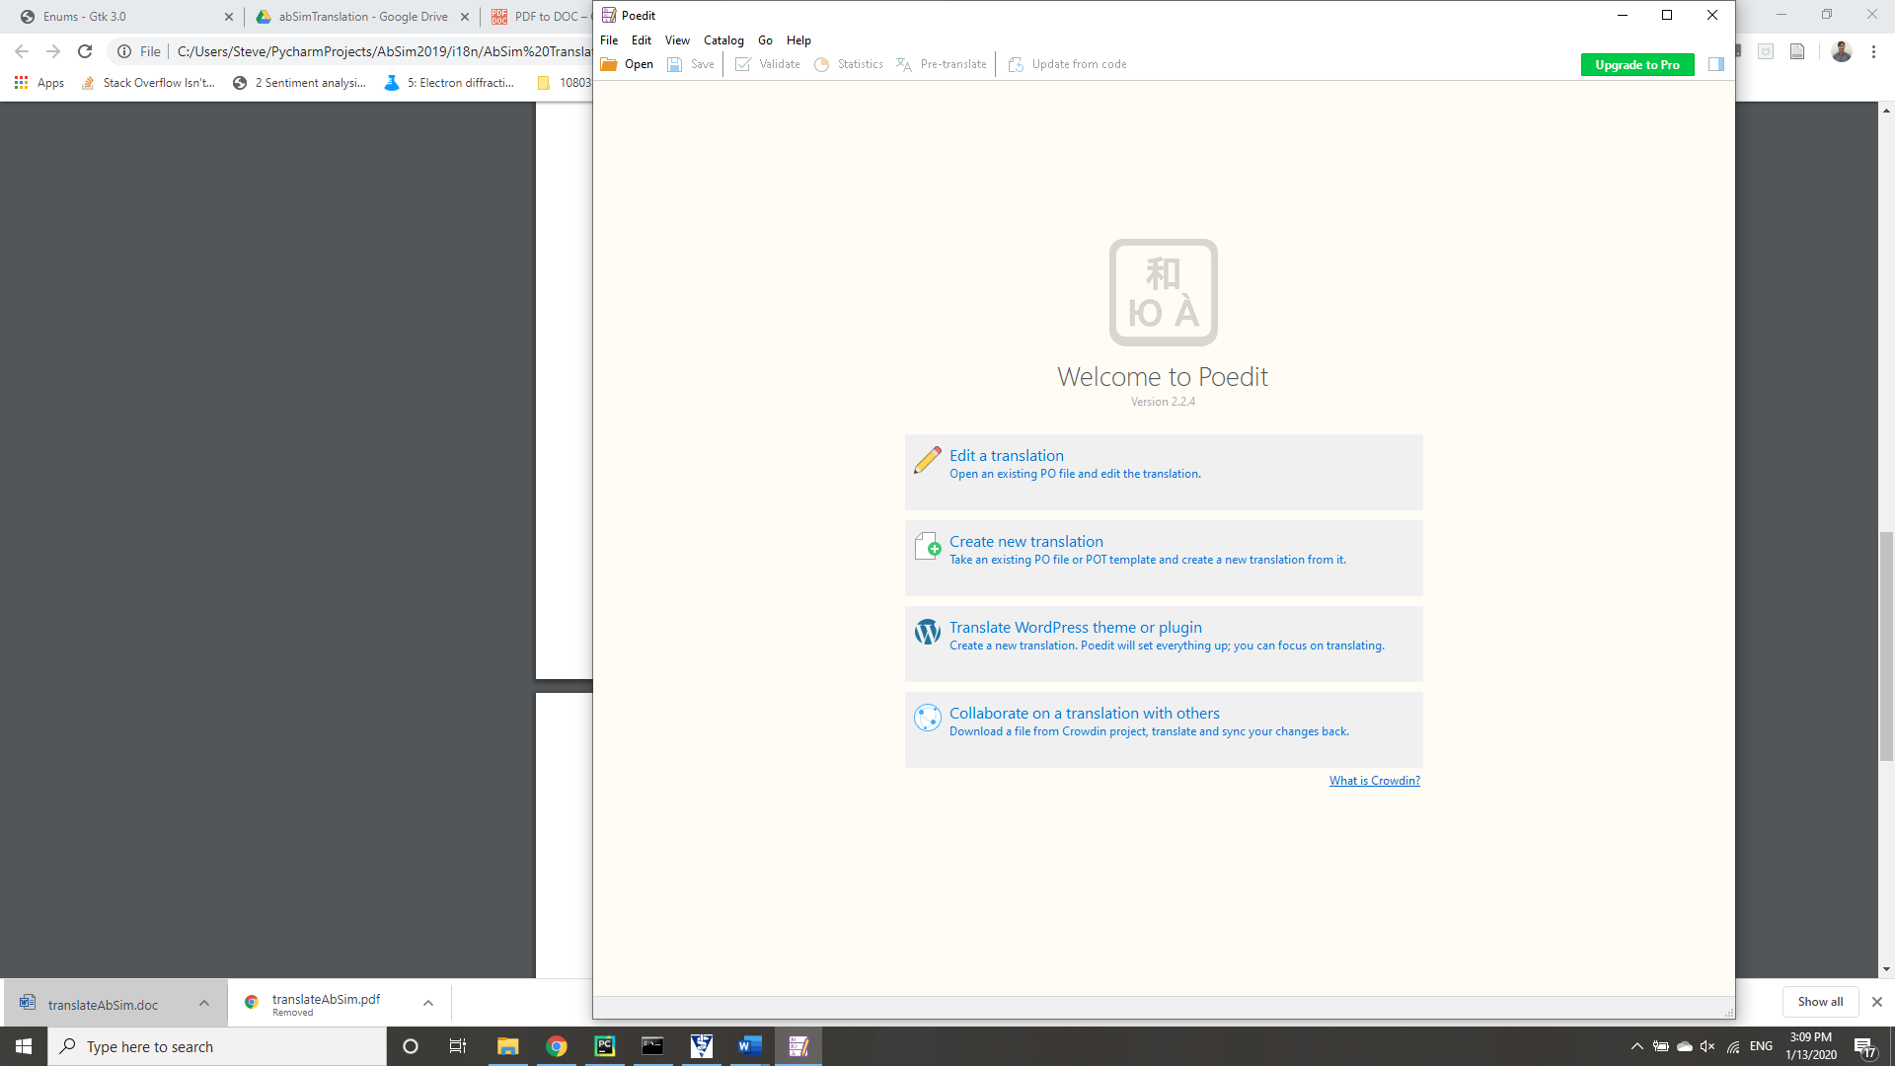

*Poedit Welcome Screen*

Please click “Create new translation,” a feature of the Poedit app that lets you take an existing PO or POT template file and create a new translation from it. Poedit will ask you to choose a file. Navigate to the folder where you’ve saved your “.pot” file and click “Open.” Poedit may pop up with some small errors. If this happens, do not panic. Just click “OK” and move on. Poedit will also ask you to choose a target language for your translation. Please choose the language you wish to see in your AbSim software.

If all went well, you should now see a table with many rows of English text. Please select the first line of text so that it is highlighted in blue (shown below):

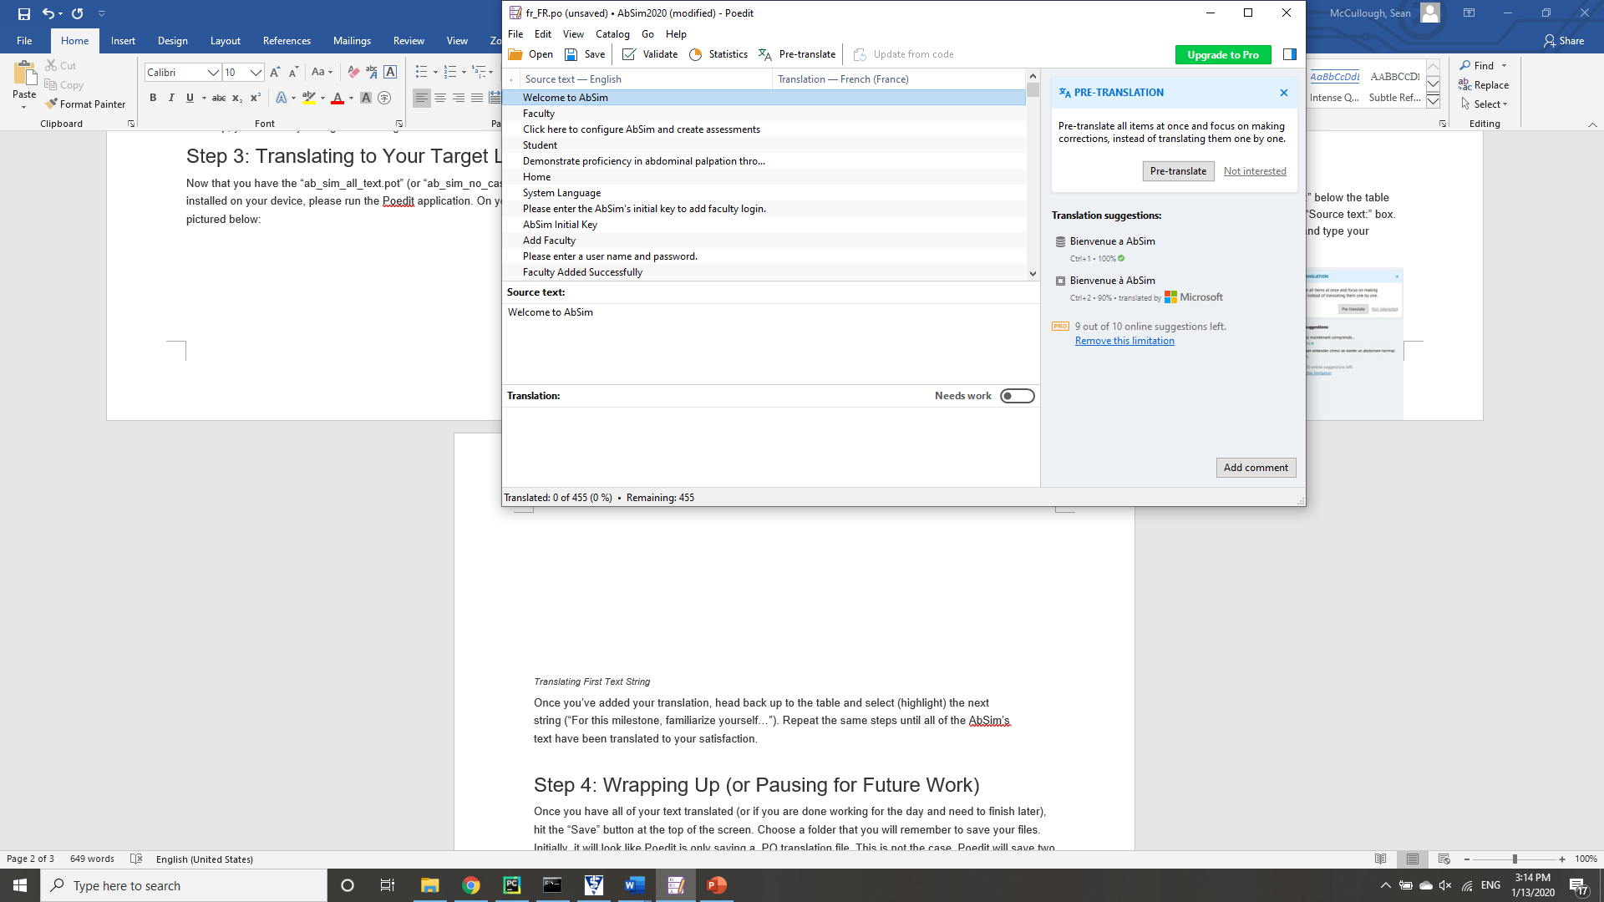

*Highlight First Text String*

Once highlighted, you should see the same text populate the box labeled “Source text:” below the table (see above). You should also notice a blank box labeled “Translation:” right under the “Source text:” box. This is where you will provide your translation. So, left click inside the translation box and type your translation for this first text string (see below):

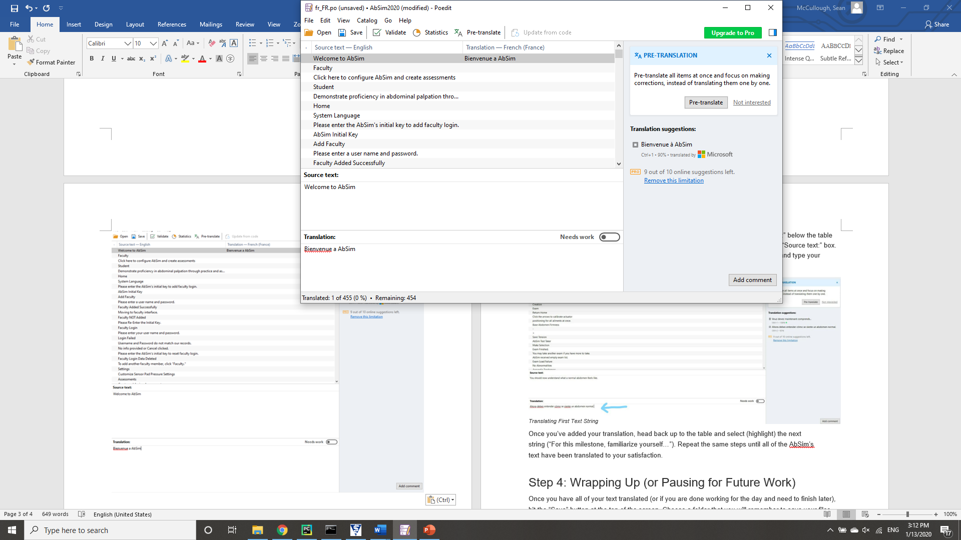

*Translating First Text String*

Once you’ve added your translation, head back up to the table and select (highlight) the next string (“For this milestone, familiarize yourself…”). Repeat the same steps until all of the AbSim’s text have been translated to your satisfaction.

Step 4: Wrapping Up (or Pausing for Future Work)

Once you have all of your text translated (or if you are done working for the day and need to finish later), hit the “Save” button at the top of the screen. Choose a folder that you will remember to save your files. Initially, it will look like Poedit is only saving a .PO translation file. This is not the case. Poedit will save two files, a .PO and a .MO. Both files are crucial for allowing AbSim’s developers to translate your interface.

Once you have made your .PO and .MO files, please send them to your AbSim representative, and our team will compile your software with the original English and the language(s) you chose.